**Instructions for IT202-M1-GettingStarted (pts. 10.00)**

1. Create a repository on GitHub: Use the format IT202-*section* as the repository name.
2. Make sure it is set to private.
3. Go to Settings (the project tab, not user account) -> Collaborators -> Add people -> Search for my ID, **llw2**, and send an invite. If there is a grader, add their name as well.

**NOTE:** Once in a while, the invite does not get created correctly, and you'll need to resend it. Keep an eye on accepting the invite since this is required for further Homework validations. A comment will be left on Canvas for the submission if the invite is missing at the time of grading - but don't wait for this. Look for my acceptance.

1. From the terminal/command line, create a new branch called **M1-GettingStarted**
2. Create a **README.md** file and add it to the branch
3. Fill in some basic details using the format:

**#** *Course/Section*

**##** *Your Name (along with a preferred nickname if you wish)*

**###** *Brief info about yourself you’d like to share*

1. Hint: after creating the file

* **git  add  README.md**
* **git  commit  -m  "my readme file."**
* **Git push  origin  M1-GettingStarted**
* Create a pull request from the branch (via GitHub)

**DO NOT** merge/close the pull request yet.

1. Create a new file called **M1-Submission.pdf** (the answers to the following deliverables will be stored in this file, so you may want to start with an editor that can **save a pdf file**)

Once done, add, commit, and push the submission file, then you may merge the Pull Request

1. Submit the direct link to this file from the master/main branch to this Canvas Homework assignment

Fill in the below Deliverables

**Deliverable 1: IDE Setup Evidence (pts. 1)**

**Sub-Task 1:** Screenshot showing requested extensions

* WakaTime (show it is started)
* MySQL (SQLTools & SQLTools MySQL/MariaDB)
* PHP Intellephense
* PDF Viewer

Make sure if the screenshot contains code that you have a relevant comment with your ucid, date, and explanation of what you’re attempting, if not maximum grade for this item is 75%.

Add a caption explaining what you’re showing in the screenshot (required for full credit)

I am showing the needed extensions WakaTime (show it is started) MySQL (SQLTools & SQLTools MySQL/MariaDB)**,** PHP Intellephense**,** PDF Viewer

**Deliverable 2: Verify Database Creation/Connectivity (pts. 1)**

**Sub-Task 1:**

Make sure if the screenshot contains code that you have a relevant comment with your ucid, date, and explanation of what you’re attempting, if not maximum grade for this item is 75%.

Add a caption explaining what you’re showing in the screenshot (required for full credit)

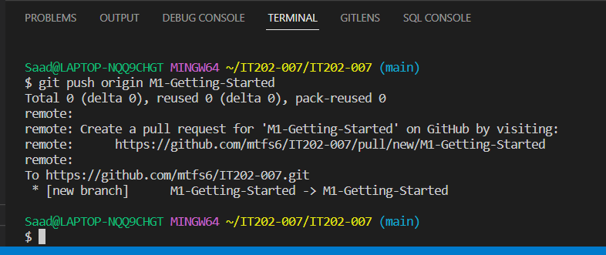

**Deliverable 3: Discussion (pts. 4)**

**Sub-Task 1:** Talk about what you learned during this module, anything interesting, new, etc.

**In this assignment, I learned how to use the tools git bash, VS Code, and GitHub.**

**How to create push\pull requests, adding th SSH key to the repo**

**Deliverable 4: Discussion (pts. 2)**

**Sub-Task 1:** Did you have any issues? If so, how did you resolve them? If no issues, just type “no issues”.

I had an issue with creating the pull request and to resolve I had to redo the ssh key part and use ssh.add.

**Deliverable 5: Pull Request Link (pts. 2)**

**Sub-Task 1:** Add the pull request link here (it should end in /pull/#)

https://github.com/mtfs6/IT202007/tree/M1-GettingStarted